**ADBMS Spring 2016**

**Zoya Kadri**

**NJIT ID- 31359832**

**UCID- zk44**

**Final Term Project**

**Sign Up for NJIT Text Message Emergency Alerts**

The codes for signup, activate and subscriber_list are attached in the end.

1.

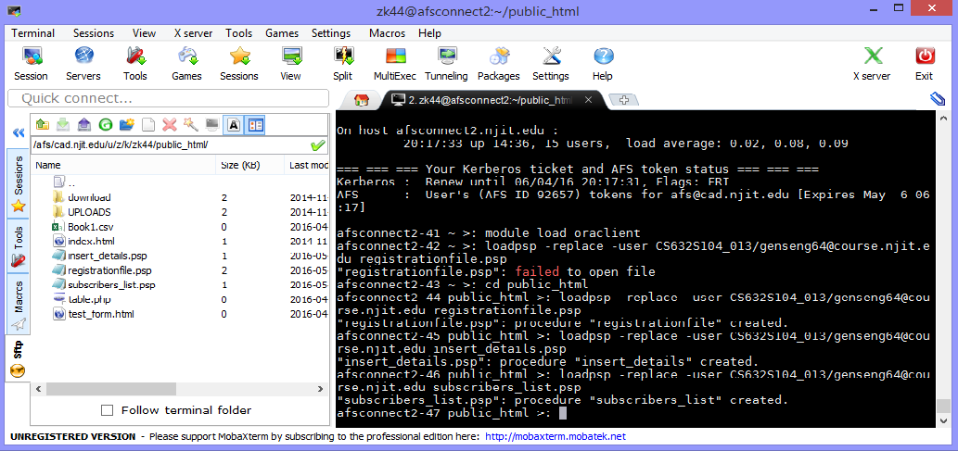

2. 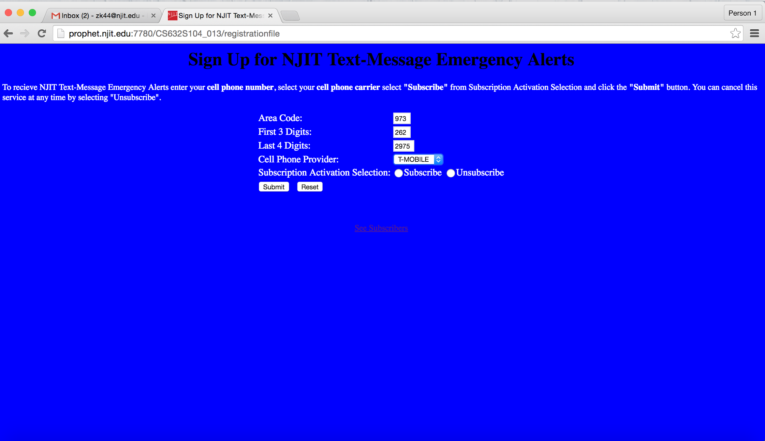

3.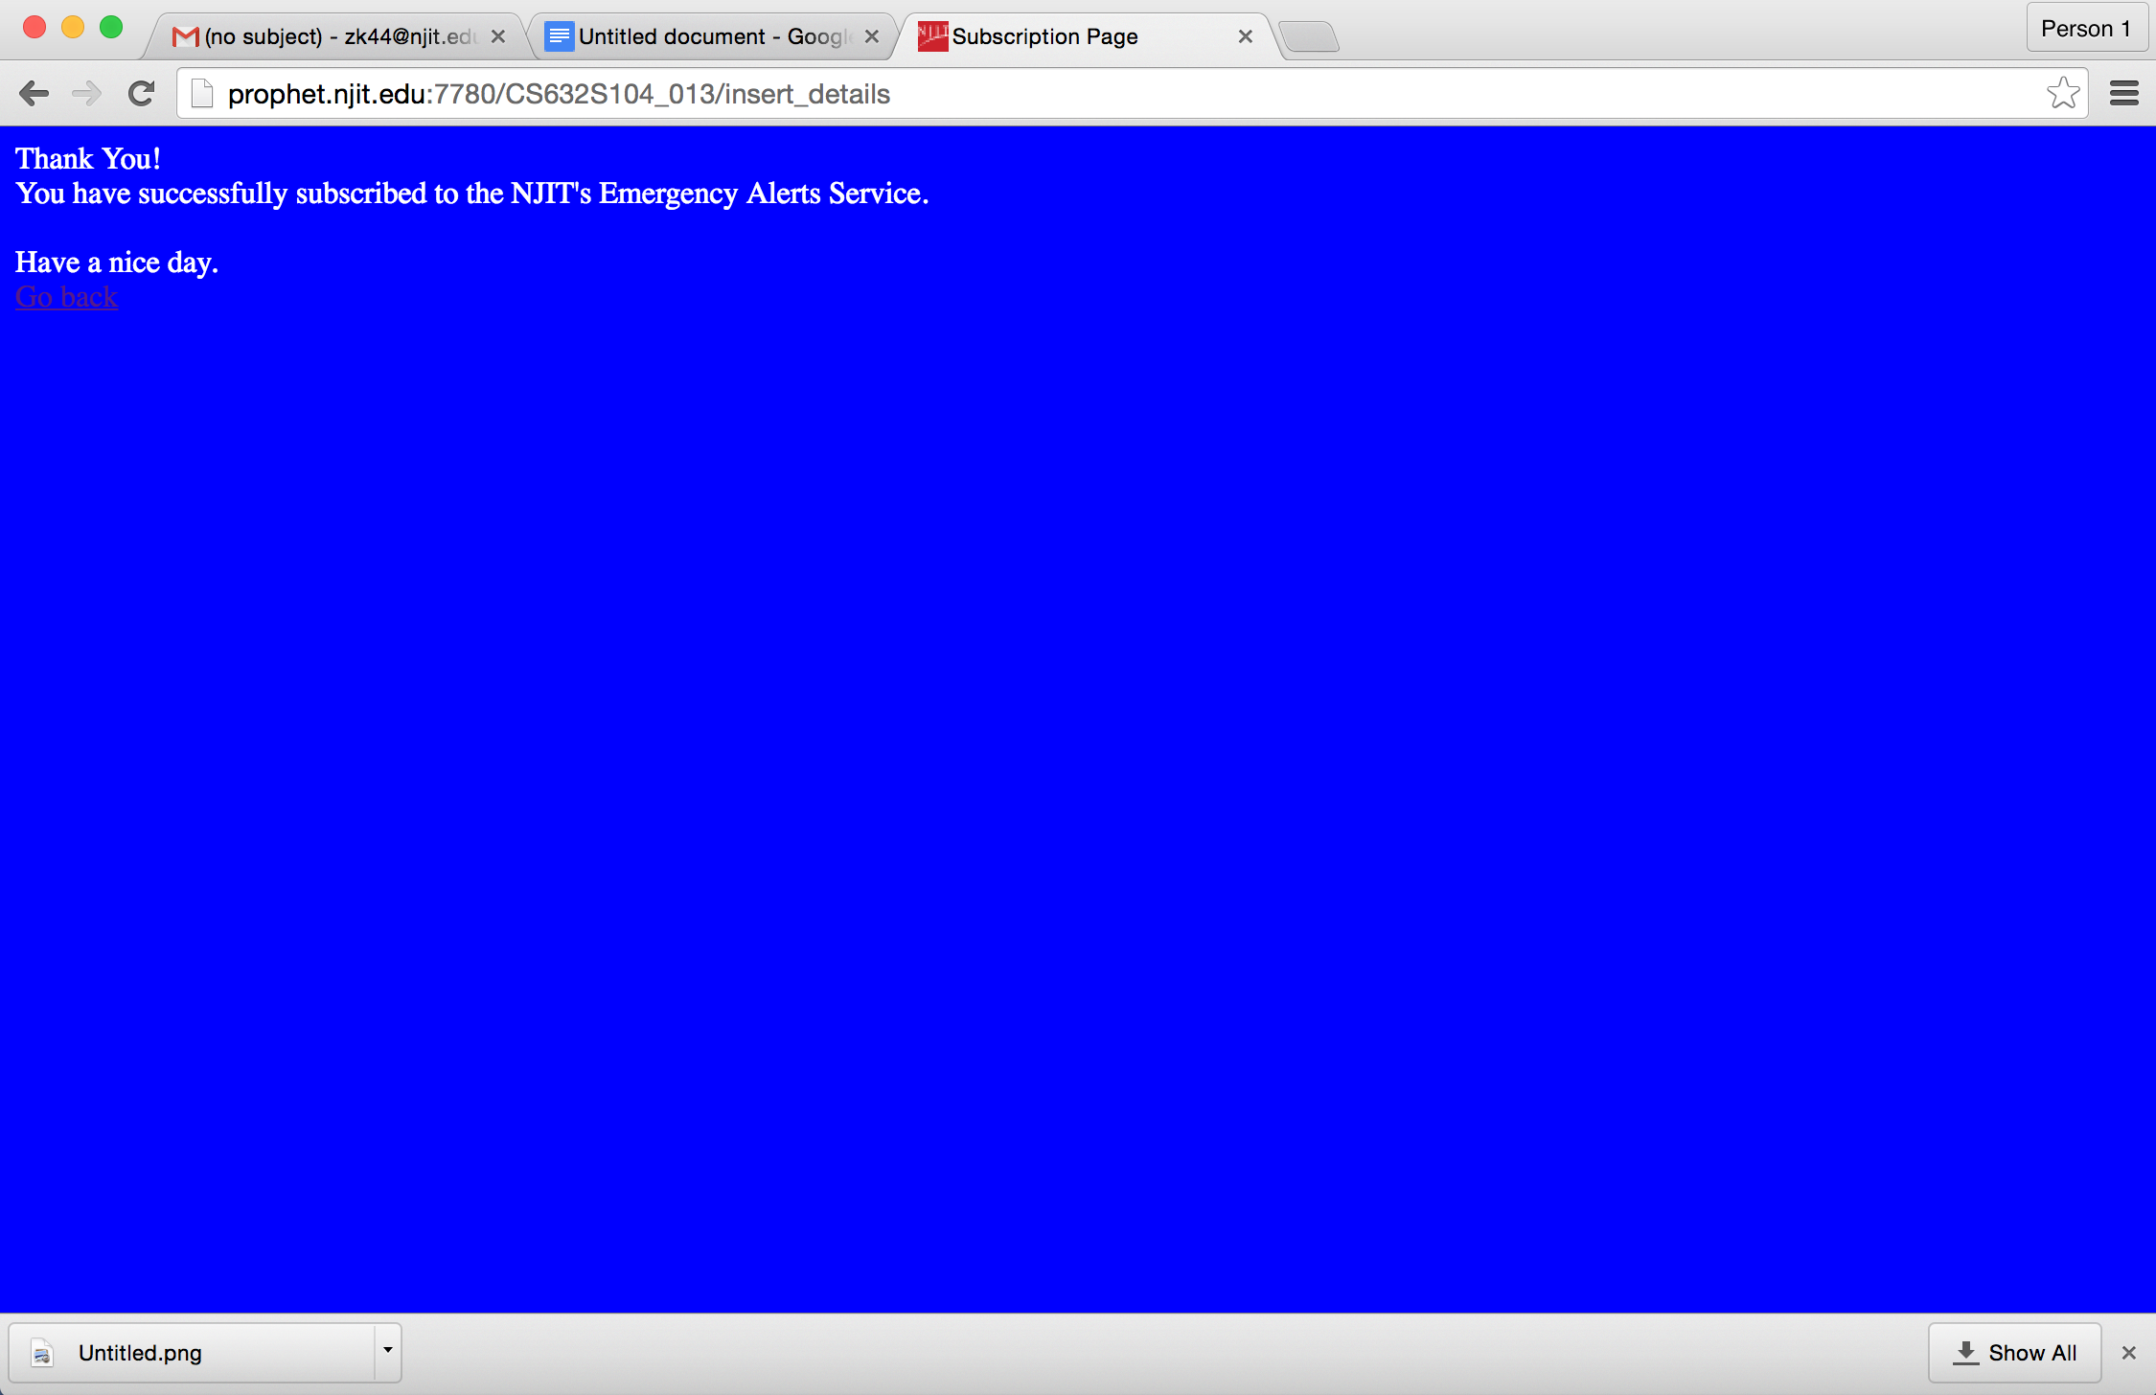

4.

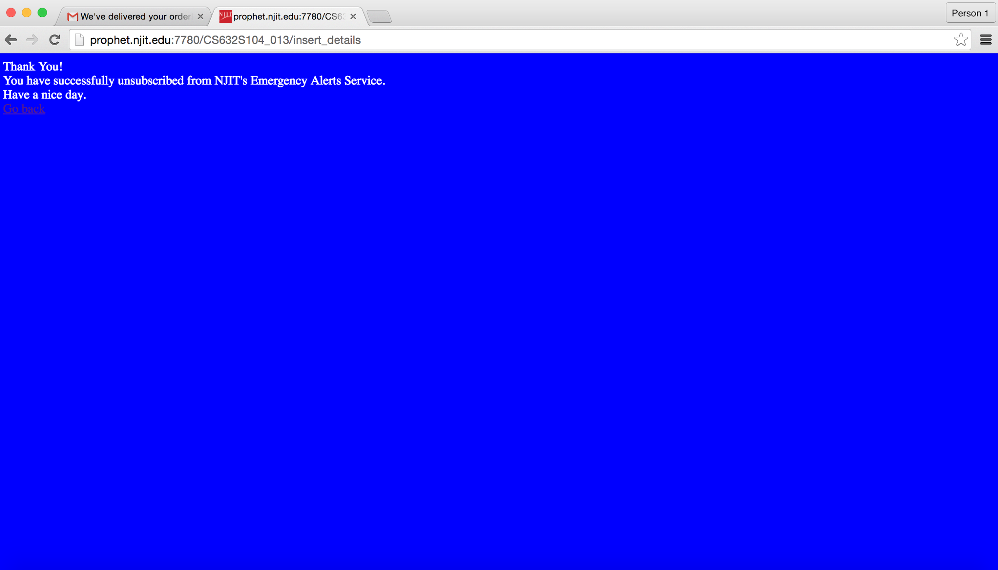

5.

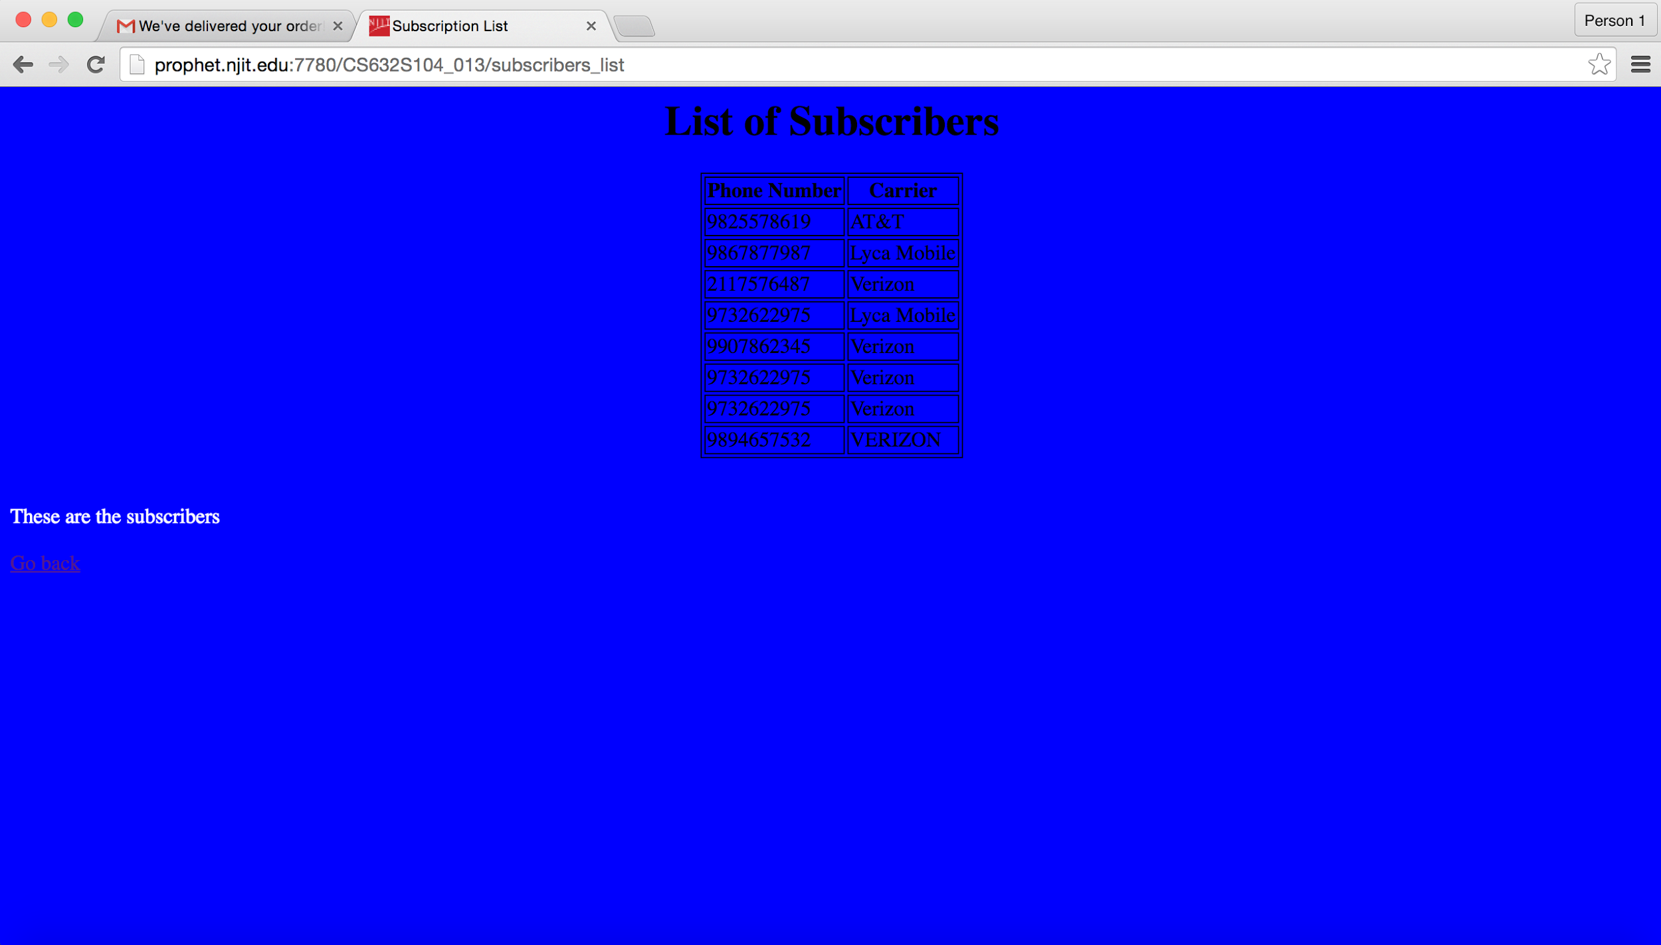

6.

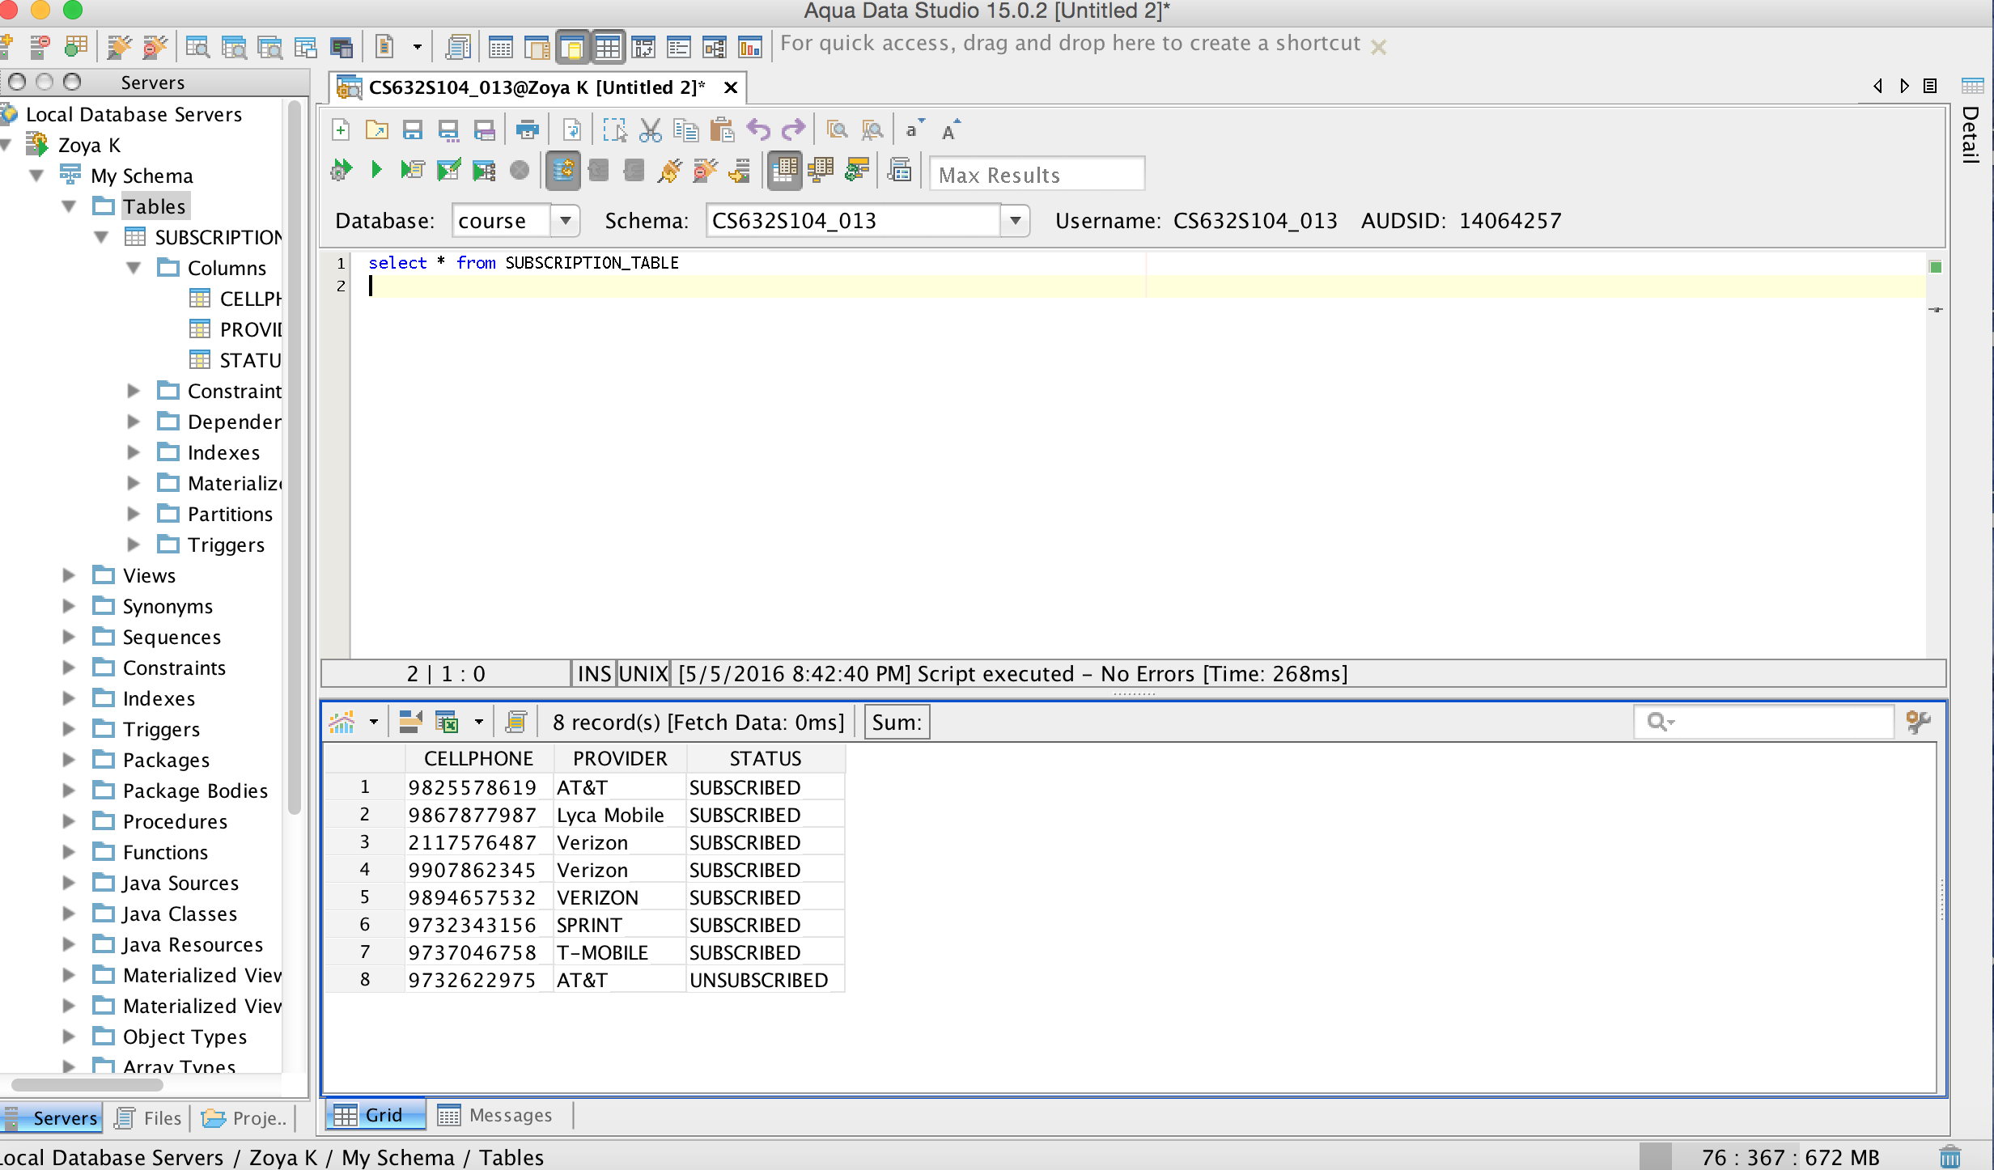

**Sign Up Page**

<%@ page language="PL/SQL" %>

<%@ plsql procedure="registrationfile" %>

<html>

<head>

<title>Sign Up for NJIT Text-Message Emergency Alerts</title>

<style>

h1

{

font-size:30px;

}

p

{

font-size:14px;

}

</style>

</head>

<h1 align="center" style="color:black">Sign Up for NJIT Text-Message Emergency Alerts</h1>

<p style="color:white">To recieve NJIT Text-Message Emergency Alerts enter your <strong>cell phone number</strong>, select your <strong>cell phone carrier</strong> select <strong>"Subscribe"</strong> from Subscription Activation Selection and click the <strong>"Submit"</strong> button. You can cancel this service at any time by selecting "Unsubscribe".</p>

<body bgcolor="blue">

<form name="form" action="insert_details" method="post">

<table align="center">

<tr><td style="color:white">Area Code: </td> <td><input type="text" name="areacode" id="areacode" size="3" maxlength="3"/></td></tr>

<tr><td style="color:white">First 3 Digits:</td> <td><input type="text" name="first3" size="3" maxlength="3"/></td></tr>

<tr><td style="color:white">Last 4 Digits:</td> <td><input type="text" name="last4" size="4" maxlength="4"/></td></tr>

<tr><td style="color:white">Cell Phone Provider:</td>

<td><select name="cellphoneprovider" id="cellphoneprovider">

<option name="AT&T">AT&T</option>

<option name="Sprint">SPRINT</option>

<option name="Verizon">VERIZON</option>

<option name="Lyca">LYCA</option>

<option name="TMobile">T-MOBILE</option>

</select></td>

</tr>

<tr>

<td style="color:white">Subscription Activation Selection: </td>

<td style="color:white" align="left"><input type="radio" name="subscription" value="subscribe">Subscribe</td>

<td style="color:white" align="left"><input type="radio" name="subscription" value="unsubscribe">Unsubscribe</td>

</tr>

<tr><td><input type="submit" name="submit" value="Submit"/>&nbsp; &nbsp;<input type="reset" name="reset"/></td></tr>

</table>

</form>

<br>

<p align="center" style="color:white"><a href="subscribers_list">See Subscribers</a></p>

</body>

</html>

**Insert_details.psp**

<%@ page language="PL/SQL" %>

<%@ plsql procedure="insert_details" %>

<%@ plsql parameter="areacode" type="NUMBER" default="NULL" %>

<%@ plsql parameter="first3" type="NUMBER" default="NULL" %>

<%@ plsql parameter="last4" type="NUMBER" default="NULL" %>

<%@ plsql parameter="cellphoneprovider" type="VARCHAR2" default="NULL" %>

<%@ plsql parameter="subscription" type="VARCHAR2" default="NULL" %>

<%@ plsql parameter="submit" type="VARCHAR2" default="NULL" %>

<html>

<%! PHONE NUMBER(10) := (((areacode*1000) + first3)*10000 + last4); %>

<% IF subscription = 'subscribe'

THEN

IF ((LENGTH(areacode) < 3) or (LENGTH(first3) < 3) or (LENGTH(last4) < 4))

THEN

NULL;

%>

<script>

alert("PLEASE INPUT IN CORRECT FORMAT. THANK YOU!");

</script>

<% ELSE

INSERT INTO SUBSCRIPTION_TABLE (CELLPHONE, PROVIDER, STATUS) VALUES (PHONE, cellphoneprovider, 'SUBSCRIBED');

COMMIT;

%>

<head>

<title>Subscription Page</title>

<style>

p1

{

align="center";

fontsize:70;

}

p2

{

fontsize:50;

}

</style>

</head>

<body bgcolor="blue"> </body>

<p1 align="center" style="color:white">Thank You!<br> You have successfully subscribed to the NJIT's Emergency Alerts Service.<br><br>Have a nice day.</p1>

<br><p2 align="center"><a href="registrationfile">Go back</a></p2>

<% END IF; %>

<% ELSIF subscription = 'unsubscribe'

THEN

UPDATE SUBSCRIPTION_TABLE SET STATUS = 'UNSUBSCRIBED' WHERE CELLPHONE = PHONE AND PROVIDER = cellphoneprovider;

COMMIT;

%>

<body bgcolor="blue"> </body>

<p3 style="color:white"> Thank You!<br> You have successfully unsubscribed from NJIT's Emergency Alerts Service.<br>Have a nice day.</p3>

<br><p4 style="color:white"><a href="registrationfile">Go back</a></p4>

<% END IF; %>

</html>

**List Of Subscribers**

<%@ page language="PL/SQL" %>

<%@ plsql procedure="subscribers_list" %>

<%@ plsql parameter="areacode" type="NUMBER" default="NULL" %>

<%@ plsql parameter="first3" type="NUMBER" default="NULL" %>

<%@ plsql parameter="last4" type="NUMBER" default="NULL" %>

<%@ plsql parameter="cellphoneprovider" type="VARCHAR2" default="NULL" %>

<%@ plsql parameter="submit" type="VARCHAR2" default="NULL" %>

<%! CURSOR cursor IS SELECT CELLPHONE, PROVIDER from SUBSCRIPTION_TABLE WHERE STATUS = 'SUBSCRIBED'; %>

<html>

<head>

<title>Subscription List</title>

<style>

table, th, td {

border: 1px solid black;

}

th

{

fontsize:16;

}

td

{

fontsize:13;

}

</style>

</head>

<body bgcolor="blue">

<h1 align="center" style="color:black">List of Subscribers </h1>

<table border="1" align="center">

<tr>

<th> Phone Number </th>

<th> Carrier </th>

</tr>

<% FOR data in cursor LOOP %>

<tr>

<td><%= data.CELLPHONE %></td>

<td><%= data.PROVIDER %></td>

</tr>

<% END LOOP; %>

</table>

<br><br>

<p1 align="center" style="color:white"> These are the subscribers</p1><br><br>

<p2 align="center" style="color:white"><a href="registrationfile">Go back</a></p2>

</body>

</html>